**Findings**

* **As Per Kaplan-Meier survival graphs for patients with the test vs standard treatment we can compare probability of survival as follow.**

**🡪**

|  |  |  |
| --- | --- | --- |
|  | **Probability of survival** | |
| **Time in Days** | **Standard Treatment** | **Test treatment** |
| 1 year (365 Days) | 5.60% | 10.80% |
| 6 Months (183 Days) | 21.00% | 21.70% |

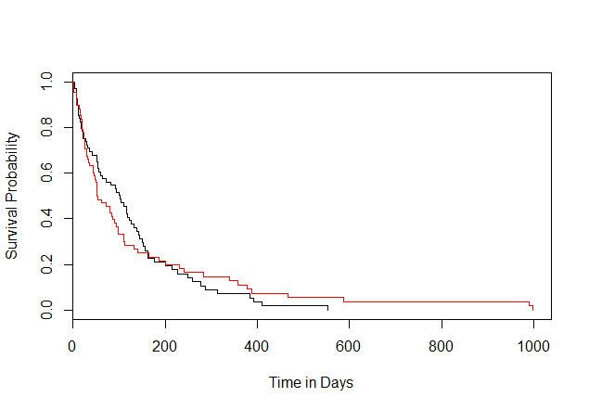 **Black – Treatment 1 (**treated with chemotherapy)

**Red - Treatment 2 (**combined with a new drug)

**Findings:-**

**1.** Most of the events happened (deaths) in early period of time (Days till 360 days)

2. In given sample we can say that after 1000 Days everyone in sample experienced the event (Death)

3. Treatment 2 (Test) has high survival probability after 1 year (Longer sustainable rate).

4. In Starting 180 Days Standard treatment has high survival probability but after 200 days it reduces as compared with Test treatment.

5. Standard treatment has less time period to sustain as we observe 0% probability of survival at 553 days as compared with test treatment.

**## For treatment 1- Standard (treated with chemotherapy) mean time of survival is 100 Days**

**## For treatment 2- Test (chemotherapy combined with a new drug) mean time of survival is 52 Days**

***Finding* – In overall Treatment 2 (Test) has less time to survive.**

* **First we apply parametric and semi parametric models on entire data and we got result as shown**

==================================================================================

Dependent variable:

-------------------------------------------------------------

`Survival in days`

Cox exponential Weibull survreg: loglogistic

prop. hazards

(1) (2) (3) (4)

----------------------------------------------------------------------------------

Treatment 0.223 -0.184 -0.185 -0.056

(0.188) (0.182) (0.182) (0.186)

`Cell Type` 0.129* -0.136* -0.137* 0.021

(0.078) (0.075) (0.075) (0.090)

PriorCh -0.008 0.011 0.011 0.003

(0.022) (0.022) (0.022) (0.023)

Months 0.002 -0.003 -0.003 0.005

(0.009) (0.009) (0.009) (0.010)

Kar_Score -0.035*** 0.035*** 0.035*** 0.040***

(0.005) (0.005) (0.005) (0.005)

Age -0.004 0.001 0.001 0.009

(0.009) (0.009) (0.009) (0.009)

Constant 3.149*** 3.154*** 1.279*

(0.710) (0.713) (0.753)

----------------------------------------------------------------------------------

Observations 137 137 137 137

R2 0.283

Max. Possible R2 0.999

Log Likelihood -483.111 -724.014 -724.012 -719.581

chi2 (df = 6) 54.415*** 48.158*** 61.370***

Wald Test 46.860*** (df = 6)

LR Test 45.545*** (df = 6)

Score (Logrank) Test 49.323*** (df = 6)

==================================================================================

Note: *p<0.1; **p<0.05; ***p<0.01

**When we apply semi parametric model and parametric models we will get the relevant Predictors which affects the Survival rate are Cell Type and Karl_Score we will interpret the effect of these.**

**Cell Type Effect (Relevant): - It has Positive coefficient in Cox Proportional Hazard model**

|  |  |  |  |
| --- | --- | --- | --- |
| **Cell Type** | **Name** | **Effect on Survival probability(Time)** | **Status** |
| Type 1 | squamous | Highest (Base) |  |
| Type 2 | small | Hazard rate increased by 13% as compared to Type 1 (less survival time) |  |
| Type 3 | adeno | Hazard rate increased by 13% as compared to Type 2 (less survival time) |  |
| Type 4 | large | Hazard rate increased by 13% as compared to Type 3(less survival time) |  |

**Karl Score (Relevant): -**

**Negative coefficient for "Kar_Score" Cox Proportional Hazard model in says that people with higher Kar_Score are less likely to experience the event (Death) i.e more time of survival.**

* **Now we will check the effects of months from diagnosis and age on survival rate as per treatment :-**

**Treatment = 1 : Impact of month s and age shown in result**

========================================================

Dependent variable:

-----------------------------------

`Survival in days`

Cox exponential Weibull

prop. hazards

(1) (2) (3)

--------------------------------------------------------

Months 0.009 -0.011 -0.011

(0.009) (0.009) (0.010)

Age 0.008 -0.014 -0.012

(0.010) (0.010) (0.011)

Constant 5.765*** 5.613***

(0.591) (0.672)

--------------------------------------------------------

Observations 137 137 137

R2 0.012

Max. Possible R2 0.999

Log Likelihood -505.091 -749.651 -747.027

chi2 (df = 2) 3.141 2.129

Wald Test 1.700 (df = 2)

LR Test 1.585 (df = 2)

Score (Logrank) Test 1.697 (df = 2)

========================================================

**Treatment = 2 ; Impact of month s and age shown in result**

========================================================

Dependent variable:

-----------------------------------

`Survival in days`

Cox exponential Weibull

prop. hazards

(1) (2) (3)

--------------------------------------------------------

Months 0.011 -0.008 -0.008

(0.018) (0.017) (0.017)

Age 0.007 -0.009 -0.009

(0.012) (0.012) (0.012)

Constant 5.421*** 5.419***

(0.700) (0.706)

--------------------------------------------------------

Observations 69 69 69

R2 0.012

Max. Possible R2 0.998

Log Likelihood -209.191 -372.116 -372.115

chi2 (df = 2) 0.909 0.889

Wald Test 0.820 (df = 2)

LR Test 0.802 (df = 2)

Score (Logrank) Test 0.820 (df = 2)

========================================================

Note: *p<0.1; **p<0.05; ***p<0.01

**Interpretation :-**

1. **As we can see in both the treatments month and age are irrelevant but it shows that for both treatments :-**

**🡪Age:- It shows that older people will more likely to experience the event that is survival probability is less but it has very marginal effect.**

**🡪Month:- higher number of months from diagnosis will more likely to experience the event that is survival probability is less but it has very marginal effect.**

1. **Month and Age has more impact on Treatment 2 (Test)**